,    **Girls Spring Football Breakfast Club at Churchfields Primary School For all KS2 Girls in Years 3, 4, 5 & 6 SEPT 10th – Dec 17th 2024** 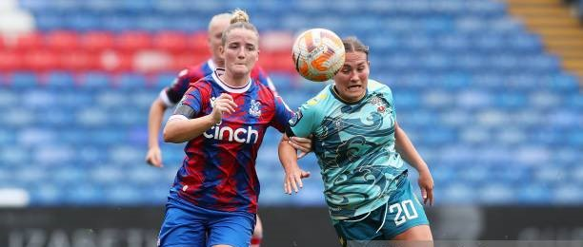

**Tuesday Breakfast Girls Football will be held at Churchfields Primary School for Years 3, 4, 5 & 6 on Tuesday 10th Sept to 17th Dec from 8am – 8.50am we will run a weekly session for the Summer Term, please contact us about registering or sign up and pay via our website, there will be 16 places available. All our coaches are FA qualified, Licensed with DBS, First Aid & Safeguarding certification and public liability and professional indemnity insurance.**

**For further information please speak to the school or contact us and to sign up and pay via our website under the pay for sessions tab** [**www.prostarsfootball.co.uk**](http://www.prostarsfootball.co.uk) **or email** [**prostarsfootball@hotmail.com**](mailto:prostarsfootball@hotmail.com) **for more details.**

**Mobile 07957 949198 or Office 020 84646453**