**SEND Information Report: 2025-2026**

Churchfields is committed to meeting the needs of all pupils. We have a fully inclusive ethos and high expectations of all the school community. We believe all pupils, regardless of their specific needs, should be offered an inclusive education, using Quality First Inclusive Teaching (QFIT) which enables all to fulfill their potential.

We carefully monitor the achievement of different groups of learners in order to make appropriate provision for ever-changing needs. We use varied strategies and teaching styles to ensure that all pupils are provided with an appropriate and accessible curriculum which allows them to develop and progress at their own level.

At Churchfields Primary School we work closely with our stakeholders to support all children in our school become excellent learners. This SEND Information Report has been produced in consultation with our Senior Leaders, MAT SEND Team, governors, teachers, support staff, parents and pupils. Any further feedback or comments on the SEND Information Report are welcome and should be addressed to [admin@churchfields.q1e.org.uk](mailto:admin@churchfields.bromley.sch.uk)

**Identification of Need**

As stated above, most children’s needs will be met through QFIT.

There may be times when children require provision that is ‘additional to’ and ‘different from’ their peers. This may mean they require a **Support Plan (SP**); this will show how they are being supported and the targets they are working towards. In some cases, a child with significant needs may require an **Education Health Care Plan (EHCP)**.

The views of families and children are a vital part of the process of identification and support of a child with SEND. Churchfields aim to work in partnership with families in order to provide the best possible support for all children. Meetings will take place to discuss your child’s needs, targets, progress and provision. Families and children (where appropriate) will be involved at every stage and all aspects of the process will be explained.

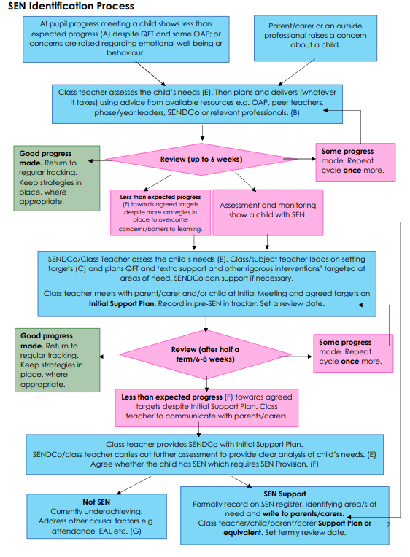

**Contacts**

If you have a concern about your child’s needs, in the first instance, please speak with their **class teacher**.

Dependent on the circumstances, you may then be directed to the **Inclusion Team**.

**Class Teachers are responsible for:**

* Adapting and refining the curriculum to respond to strengths and needs of all pupils
* Checking on the progress of your child and identifying, planning and delivery of any additional support
* Writing SPs (with support of the Inclusion Team)
* Directing support staff in delivering interventions (with support of Phase Leader / Inclusion Team)
* Applying the school's SEND policy through daily practice.

**Inclusion Team (Liz Williams: Mainstream SENCo & Leia Stephenson: ARC Lead & SENCo and Sally White Deputy Headteacher) is responsible for:**

* Coordinating provision for children with special educational needs across the whole school
* Liaising with external agencies offering advice and support to help pupils and families.
* Providing advice and facilitating training to ensure all staff are skilled and confident about meeting a range of different needs within the school
* Attending meetings with families and external agencies
* Acting as a point of contact for families seeking support including; foodbank, school uniform, wraparound care etc.
* Building and maintaining strong relationships with families of vulnerable children
* Monitoring school attendance
* Acting as a signpost for families to relevant agencies.

Ensuring parents are:

* Involved in supporting their child’s learning and access
* Kept informed about the range and level of support offered to their child
* Included in reviewing their child’s progress
* Consulted about planning successful movement (transition) to a new class or school.

**Director of SEN for Q1E (Erica Brownlee) is responsible for:**

* All of the above as well as
* Developing provision for children with additional needs and training staff as required, providing advice and support for all children, staff and parents across the MAT.

**Headteacher (Sarah Atherton) is responsible for:**

* Day to day management of all aspects of the school, including the provision made for pupils with SEND in mainstream and The ARC.

**SEN Governor / Trustee (Karen Parkinson & Tess Marjoram) are responsible for:**

* Supporting the school to evaluate and develop quality and impact of provision for pupils with SEND across the mainstream The ARC.

**Contact Details:**

Existing pupils: Mainstream SENCo: [SEND@churchfields.q1e.org.uk](mailto:SEND@churchfields.q1e.org.uk)

ARC SENCo: [ARC@churchfields.q1e.org.uk](mailto:ARC@churchfields.q1e.org.uk)

Prospective pupils: [admin@churchfields.q1e.org.uk](mailto:admin@churchfields.q1e.org.uk)

**Support Offered**

Daily planning considers individual needs and requirements, including targets from SPs, FIPs, EHCPs or Behaviour Support Plans (BSP).

Adaptation is approached in a range of ways to support access and ensure that all pupils can experience success and challenge in their learning; this is met through Quality First Teaching.

Grouping arrangements and additional adults are organised flexibly, to maximise learning opportunities for all, with the long-term goal of developing independent learning skills and avoid pupils’ over-reliance and dependence on adult support.

For children with medical needs, Individual Health Plans are written with parents and overseen by the Inclusion Team.

We also offer different forms of additional provision, specialist resources and equipment.

These **can** include:

* Access to specific resources
* Counselling
* Music Therapy
* Speech and Language Therapy assessment / input
* Occupational Therapy assessment / input
* Educational Psychologist assessment / input
* Social Skills groups
* Lunchtime club
* ELSA (Emotional Literacy Support)
* Specific intervention groups run across the Key Stages
* Soundfield system in some classrooms and the hall.

These additional provisions are overseen by the Inclusion Team and are implemented by Teachers and Support Staff.

All additional provisions and interventions are designed to match the needs of the child and cover the 4 areas of need under the SEND Code of Practice:

**Communication and Interaction:** We have a Speech and Language Therapist who works closely with the school to offer advice and set targets for children who need support in this area. Follow up input is led by trained support staff across the school.

**Cognition and Learning:** Intervention groups are run across the school to support the learning of our children. They have clear targets and are regularly reviewed for impact.

**Social, Emotional and Mental Health:** We have a strong ELSA program, alongside pastoral groups including breakfast and lunchtime clubs for those who need them. Our school counsellor is in school each week and works with many children across the school. We also have a music therapist who regularly attend and work with small groups of children. Individual Behaviour Plans maybe written and discussed with parents to decide on strategies to best support the child.

**Sensory and/or Physical:** A Soundfield system is fitted in the hall and in some classrooms to support children with a hearing impairment. Access plans are written as needed in order to support children’s physical needs.

We also have a Sensory Room, available to all children with sensory needs, as well as facilities and staff trained in Sensory Circuits.

**Parent Support Agency Contacts**

There are a number of local agencies that provide support services to parents of SEND pupils. Among these are:

Information, Advice & Support Service (IASS)

<https://bromlayiass.org.uk>

Bromley Parent Voice

[www.bromleyparentvoice.org.uk](http://www.bromleyparentvoice.org.uk)

Bromley Children Project <https://www.bromley.gov.uk/info/200071/parental_support/769/bromley_children_project>

**Staff Knowledge, Training and Skills**

The Inclusion Team actively engages in a range of opportunities to share best practice and keep abreast of current, local and national initiatives and policy to support pupils with SEND.

Churchfields and Q1E regularly review, evaluate and develop the provision for all SEND children.

An on-going program of training is in place to ensure that teachers and support staff have appropriate skills and knowledge in areas that will improve their teaching and support of children with SEND and Additional Needs.

Staff training includes:

* Effective teaching and learning drawn from research and best practice
* Training Meetings to update staff on the Code of Practice and areas of need in school
* Sensory Support
* Visual support
* The use of Colourful Semantics
* Running SaLT interventions
* Understanding ASD & ADHD
* Supporting positive learning behaviour
* The use of manipulatives in the classroom
* De-escalation
* Quality First Inclusive Strategies
* Understanding attachment and trauma

**Assessment, Planning and Review (including access to assessments)**

Termly Parents’ Evenings are held with the Class Teacher. Between these times, you may request a meeting with the Class Teacher by contacting them directly via the class email or Admin Team.

Teachers regularly assess children’s progress across the curriculum and will work with the Inclusion and wider Leadership Teams to ensure appropriate support strategies are put in place to understand and support those not making expected levels of progress. These could include targeted small group and / or individual. The views of the child will be given consideration, where appropriate.

This additional support is documented on a Class Provision List, reviewed regularly by the class teacher and Inclusion Team. A termly SP is completed for those on the SEN Register.

In consultation with families, the class teacher and Inclusion Team agree termly SMART (**s**pecific, **m**easurable, **a**chievable, **r**ealistic & **t**imebound) targets which prioritise key areas to address. Where external agencies are involved, their advice and recommendations are included.

Actions agreed consider each pupil’s strengths as well as their difficulties. Children with an SP are encouraged to contribute by identifying their own strengths and where they feel that they need extra help. This information is shared with each new teacher during a handover meeting.

Some children may need a Behaviour Support Plan, which is reviewed regularly, in line with our behaviour policy which can be found here <https://www.churchfields-q1e.org.uk/our-school/policies/>

Additional funding can be available for children who have significant needs. This can be accessed using the Local Authority process and the guidance in the Banded Funding Criteria. Where this is agreed, a Funded Inclusion Plan (FIP) will be drawn up and implemented.

Further details about this process will be explained in the LA Local Offer (<https://www.bromley.gov.uk/LocalOffer>).

Support Plans (SP) are reviewed three times a year. An EHCP Annual Review is held each year with families, relevant external agencies and when appropriate, pupils are invited to this review and their contribution is valued. The impact of support offered is considered along with the progress towards targets set. Support arrangements will be updated and revised accordingly. If not involved already, this might include referral to external agencies. The outcomes of these meetings will be formally recorded.

For some pupils, additional arrangements and adjustments can be made to enable them to fully access a range of academic assessments.

This could include:

* Additional time
* Rest breaks
* Enlarged texts for visually impaired children
* Modified audio spelling tests for the hearing impaired
* The use of a scribe or reader for English and maths tests.

The Inclusion Team will inform families about eligibility and applications for these arrangements. Only tests and assessors authorised by the school and recognised by NCA can be accepted for access arrangements for public examinations.

**Transitions**

Children and young people with SEND can become particularly anxious about moving on and change, so we seek to support successful transitions to the next phase of life by:

* **Starting at Churchfields**. The Inclusion Team and EYFS lead will attend the Bromley Transition Day where pre-school and primary schools work together to share information on all children with SEND. We will contact the child’s current provision and always try to visit the child and gain information from their key worker. Where appropriate, we will make a transition booklet to give to the child and parents will have opportunities to visit the school before they start.
* **Moving to the Next Class.** An information sharing meeting will take place with the receiving teacher. If appropriate, there will be opportunities for your child to visit the new class and meet the teacher and other key staff. We will make a transition booklet to support the change.
* **Moving to secondary school.** The Inclusion Team and UKS2 staff will attend the Bromley Transition Day where primary and secondary schools work together to share information on all children with SEND. We will also meet individually with secondary staff, where necessary, to ensure they are fully aware of the children’s needs before they join. Multi-agency meetings may be arranged to create a more detailed transition plan. Successful arrangements and interventions currently used to support your child will be shared with the receiving school and additional visits to the new setting may be planned to help your child become familiar with the new setting and to reduce any anxieties.
* **Moving to another school.** We will work with the new school and share information about the support that your child receives with us. It may be necessary for them to come and visit or your child to visit their new school to ensure the transition goes smoothly.

**ARC (Additionally Resourced Classes)**

Churchfields has an additional resourced provision (ARP) for pupils with severe and complex needs. All children in The ARC have an EHCP and are able to access more individualised teaching and support through a smaller class and higher level of adult support.

This provision is led by our ARC SENCo & Class Teacher, Leia Stephenson.

The ARC curriculum is designed to meet the needs of children with complex difficulties and enable them to progress with their learning whilst also following many aspects of the mainstream school curriculum.

Where appropriate for their needs and level of development, children in The ARC take part in inclusion sessions, within the mainstream classes, for some subjects.

Children are placed within the ARC by Bromley and to access a place, they must have Churchfields ARP named on their EHCP.

For more information on the ARC, please look on our website <https://www.churchfields-q1e.org.uk/our-learning/the-arc-specialist-provision/>

**Enrichment**

There are a number of extra-curricular enrichment clubs and groups, which children are able to join and e part of. These range from football to cooking and choir. See the full list here <https://www.churchfields-q1e.org.uk/for-our-parentscarers/extra-curricular-clubs/>

**Complaints**

If there is something you are not satisfied with regarding the SEND policy and practices, we urge you to speak to one us as soon as possible.

In the first instance, please speak to the class teacher or Inclusion Team.

Following this, if you feel that your child’s needs are still not being met, you should make an appointment to see the Head Teacher. If concerns are still unresolved, parents may wish to contact the Information, Support and Advice or engage with the school complaints procedure.

**School Day**

The timings of the school day are as follows:

Nursery: 9.00 – 3.30

Reception: 8.55– 3.25  
ARC: 8.40 – 3.10

KS1: 8.50 – 3.15

KS2: 8.50 – 3.20